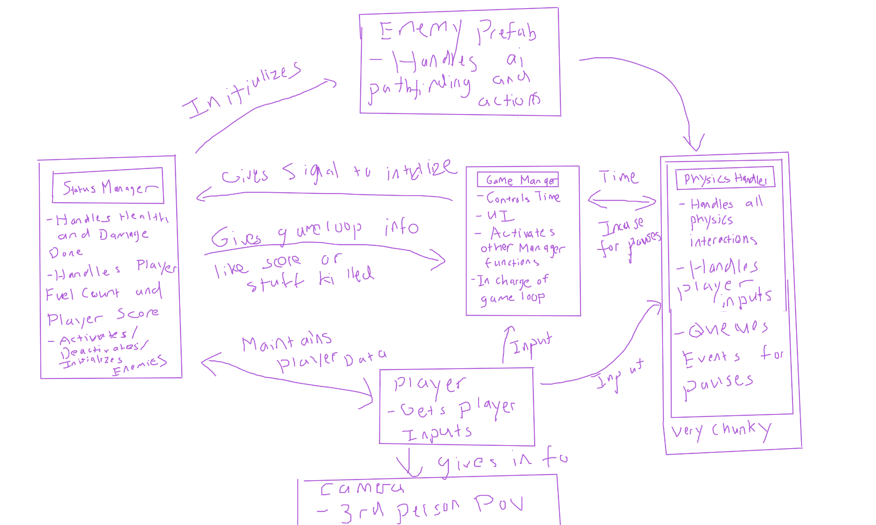

I mainly made a chart for how I want the game to be structured. I did not work on it too much as I have to quickly build a portfolio website for internships. Most internships are due at September 29th and I have yet to make a website as of writing this so I will work on most of the game develpment next week when I do not have to worry about internships. However I do have most of the game planned out as I plan on making a bare bones grappling system for the character. I will probably resort to doing a line tracing method for the grappling hooks and make them slowly reel your character into them. For the “titans” I will have cubes that jump at you and if you touch the bottom of them you get crushed and die instantly. This should be good enough for most of the logic. I might implement a pathfinding systems but making the cubes go towards you should work for most cases. Once again sorry for lack of content but internships have taken a priority rn.